**SDI DATABASE SERVERS**

**May 2018**

**ATD DBA Team**

**Contents**

1. **PRODUCTION DATABASE ………………………………………………………..2**
2. **AWS DATABASE …………………………………………………………………….13**
3. **DEVELOPMENT DATABASE …………………………………………………….16**
4. **APPENDIX A - CREATING BACKUP IN PRODUCTION SQL …………18**
5. **APPENDIX B – DBA TASKS ………………………………………………………29**
6. **Check server logs ………………………………………………………………29**
7. **Check CPU and memory use ………………………………………………31**
8. **Check partitions health ……………………………………………………..33**
9. **Check database instance logs …………………………………………….36**
10. **Check database instance activity monitor ………………………….38**
11. **Check backups in E:\Backups ……………………………………………..40**
12. **Restore backups and compare data ……………………………………41**

This document describes the **Self Determination Inventory (SDI)** Production, QA, and Development SQL Server databases.

1. **PRODUCTION DATABASE**

The **Production** database resides on a Windows Server 2016 Data Center, **Aaiprdsdidb.home.ku.edu,** which is a virtual machine maintained by KU IT. The specifications are shown below.

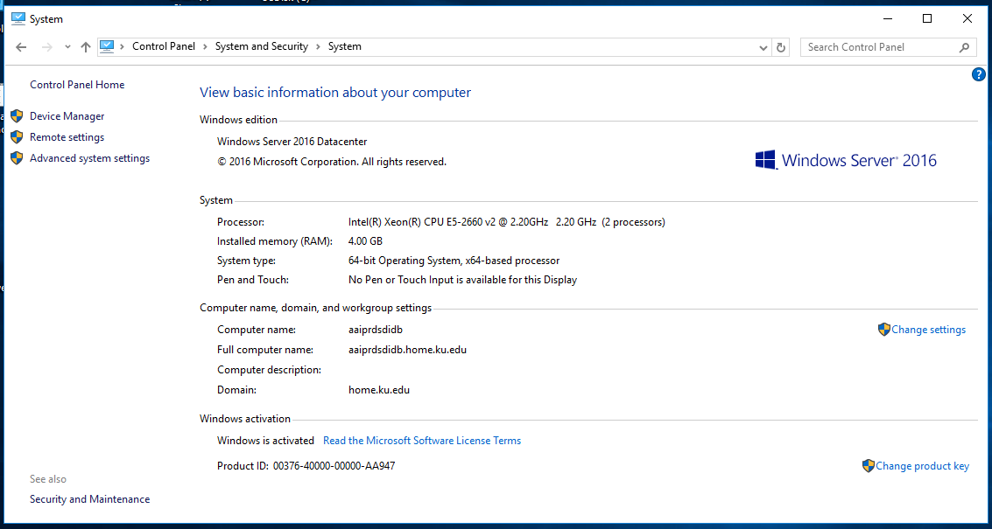

To login use the Remote Desktop Connection and your admin account (like s851g945**_**a).

Serve policy requires maximum password age to be no more than 180 days.

You cannot be on a VPN when you connect. If you had started Cisco AnyConnect (or other VPN) you need to stop it.

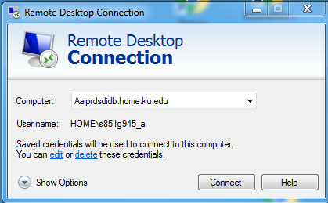

It is a good practice to avoid staying logged in when it is not necessary. There is a limit of two users that can login at the same time.

When you finish working sign out, DO NOT power off.

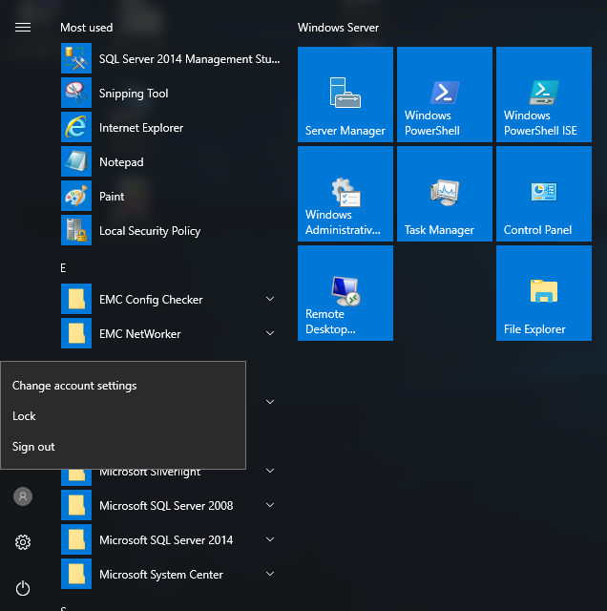

KU IT run updates when available, on Wednesdays between 12Am and 6AM.

The server has the following storage devices

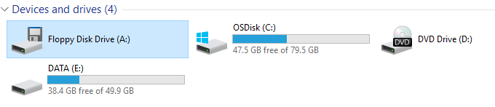

C: is for the operating system and applications, not for data. E: is for data.

Database files in the E partition are in folders:

SDIdata – where database (.mdf) and log (.ldf) files reside.

Backups – where database backup files (.BAK) and job text files (.txt) reside.

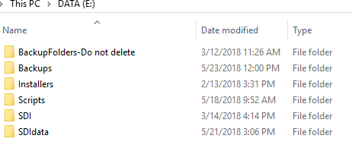

The Scripts folder is meant for storing “.sql” files sued for various queries in SDI.

The Installers folder has the database installation files.

The SDI folder contains files from the original installation of SDI on another server.

The **version** of the database used at the time of publication is MS **SQL 2014** with Service Pack 1.

12.0.4100.1 SP1 Standard Edition (64-bit) v4.0.30319

Please note that, there is a newer service pack (SP2). The requirement was to use the very same version of database as the one used at LSI. That is also the reason for using an older version of SQL (when version 2017 is available).

Historical note: The license purchased was for SQL 2017. Staley and/or Sue verified with the vendor that an older version can be used with that licens.

The (instance) Server Name is AAIPRDSDIDB

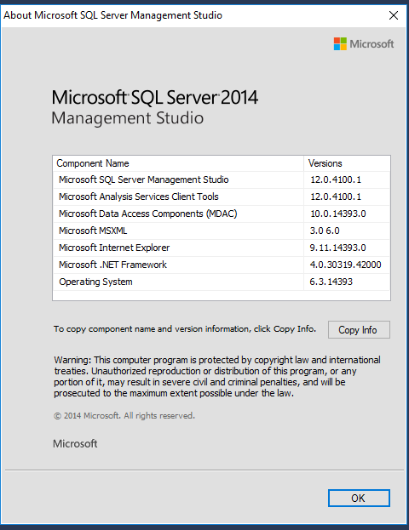

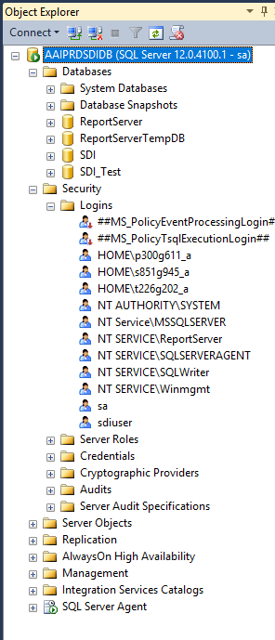

Instance Users (passwords given to DBA) are: sa (system admin), sdiuser for application (password given to Nathan Tipton too).

Users with role of sysadmin and SDI database owner (network login passwords): s851g945_a, p300g611_a, t226g202_a. Passwords are personal. Users will be prompted to change these.

The SDI database used for the application is **SDI**.

The database DSI_Test is used for testing purposes, recovery from backup tests, etc. It can be deleted and recreated as needed. At the time of publication, SDI_Test is a restored copy of SDI.

Database files are located in E:\SDIdata for both databases.

The SDI database **Recovery Model** is Full.

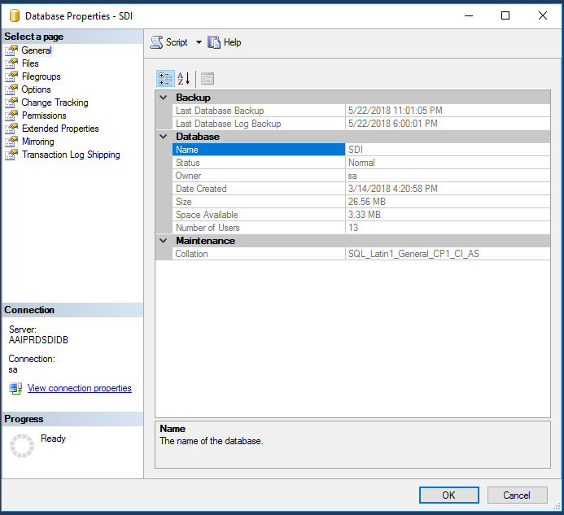

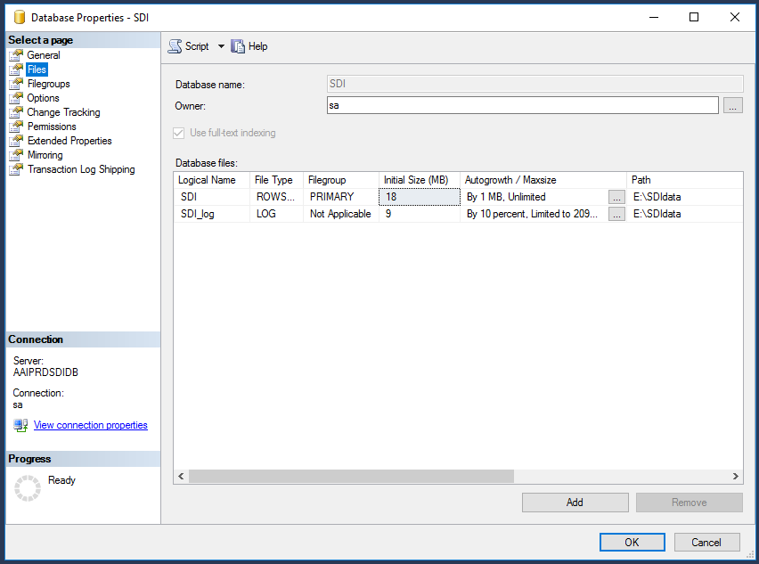

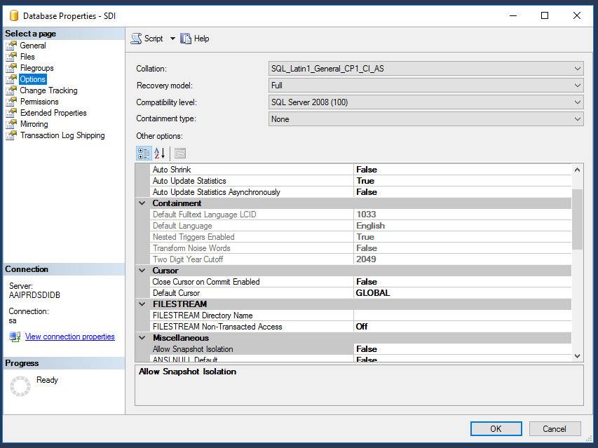

SDI **Backup** files are in E:\Backups, **retained** for 8 days.

Backup jobs for database and logs are found in Maintenance Plan, scheduled to run at 12 PM and 6PM.

Backup files have a date and “.BAK” extension. There should be two files for every days of the last 8 days.

There should be two text files for each database backup for every day of the last 8 days, and two text files for each log file for every days of the last 8 days. That is, 16 files of each of these text files.

Cleaning backup jobs remove “.BAK” and “.txt” files older than 8 days. There are 8 text files for the cleaning of backup files, and 8 text files for the cleanup of text files related to backup.

Appendix A describes how to create a backup.

In addition to the local backups, KU IT take tape backups of the E partition.

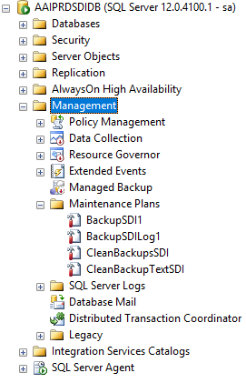

In order to modify a maintenance plan, specifically the backups, double click on a plan

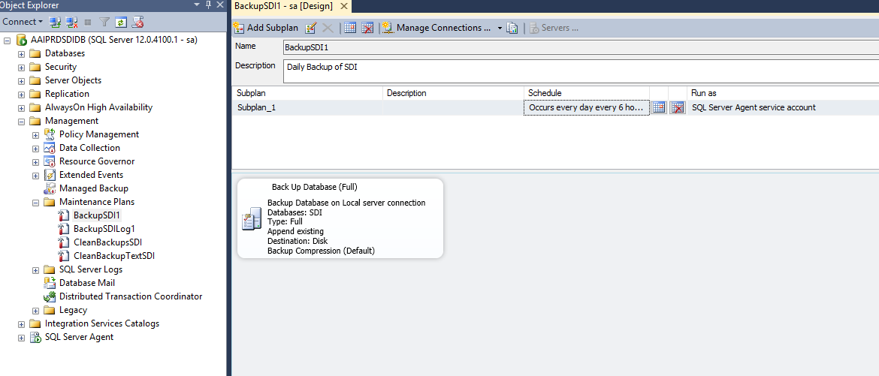

Jobs running the maintenance plans are under SQK Server Agent. In order to modify a job double click on it

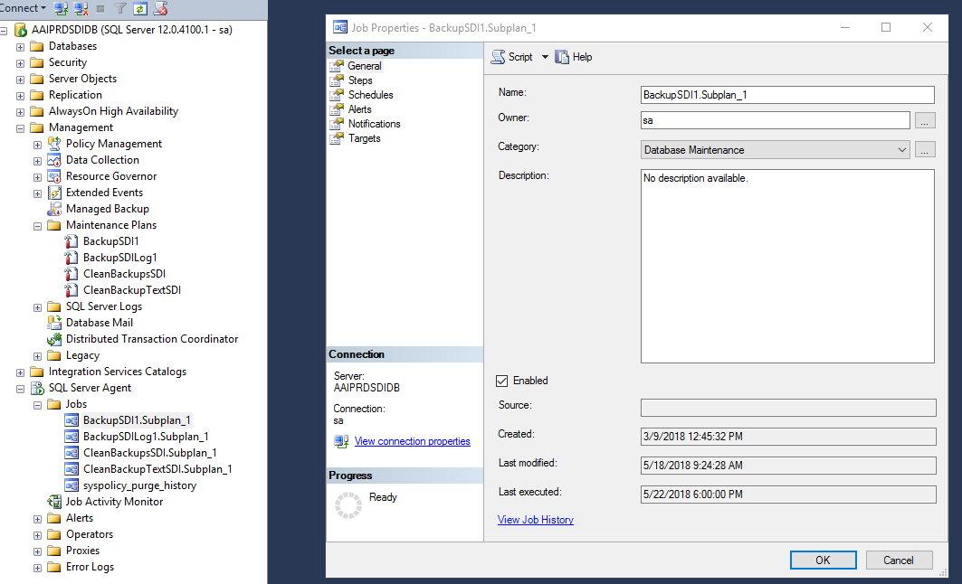

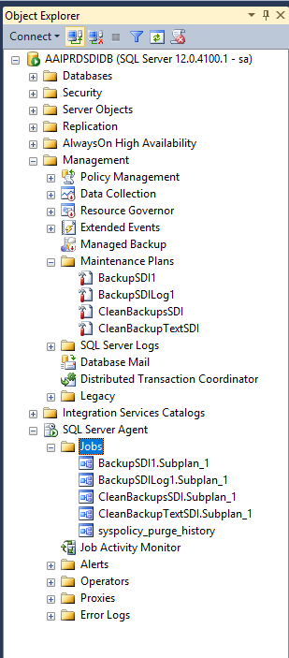

The schema for the SDI database was given to DBA in a separate file (SDI_Prod_Schema.sql). It can be found in E:\Scripts

**DBA Tasks (see Appendix B for detailed description)**:

These tasks are performed as needed in order to maintain the server and database.

In addition, the DBA teat may be asked to modify the database by creating new objects, granting permissions, modifying data, etc.

Check server logs.

Check CPU and memory use.

Check partitions health.

Check database instance logs.

Check database instance activity monitor.

Check backups in E:\Backups.

Restore backups and compare data with that of the SDI database.

1. **AWS DATABASE**

**UPDATE:**

**As of 5/25/2018 the SDI instance on AWS no longer exists.**

**A snapshot exists as shown**

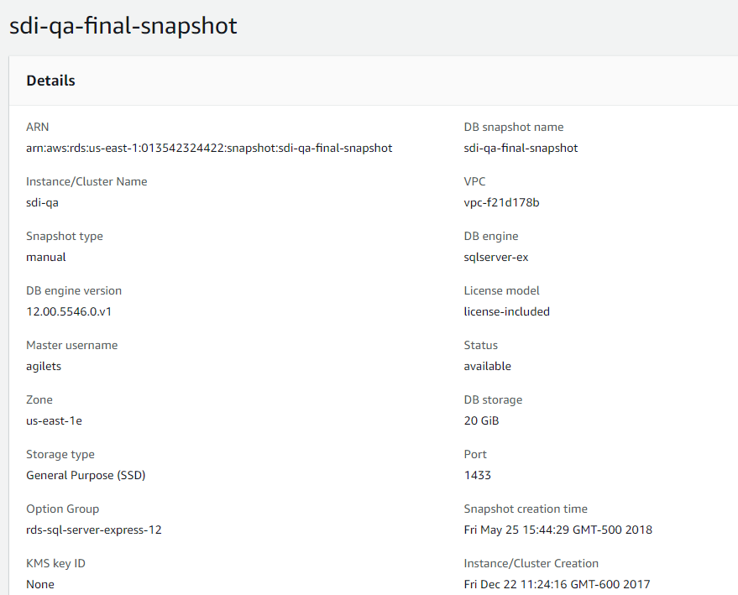

PREVIOUS POST:

The SDI database for QA resides in AWS RDS instance **sdi-qa**, with a class of db.t2.micro.

The SDI QA instance utilizes the Engine SQL Server Express Edition 12.00.5546.0.v1, which is **SQL 2014 Express**.

The screenshot below shows the various groups that this instance uses

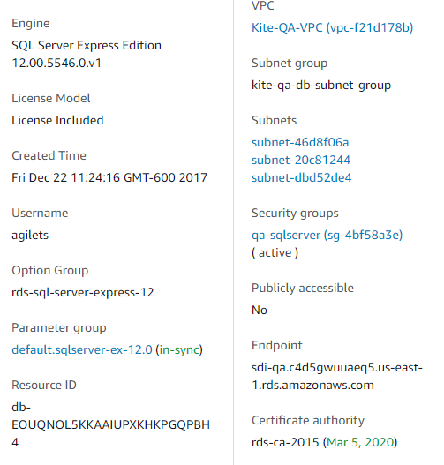

The instance is backed up with retention of two days.

The endpoint is **sdi-qa.c4d5gwuuaeq5.us-east-1.rds.amazonaws.com**

Users (passwords given to DBA) agilets, sdiuser, (there is no sa).

The application database is SDI.

There could be test databases too. At the time of publication there was a test databases, SDI_Test (empty shell of SDI).

It is necessary to open dbutil.mgmt.east.cete.us

It is necessary to have a tunnel sdi-qa.c4d5gwuuaeq5.us-east-1.rds.amazonaws.com:1433 with a localhost port.

In SQL Server Management Studio enter Server Name 127.0.0.1,9004 (here 9004 is the localhost port chosen, but it will vary, based on individual’s numbering).

Please note that in this connection there is a comma (,) not a semi colon (:) after the port number.

Please note that we do not use here “localhost” but the IP of localhost (127.0.0.1).

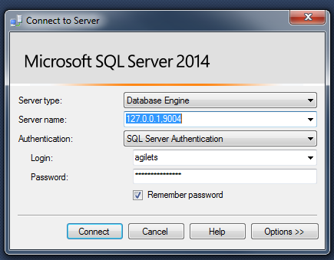

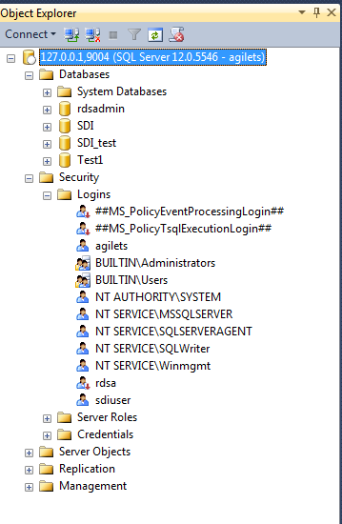

1. **DEVELOPMENT DATABASE**

The development database is located on server sdidb1.dev.cete.us

When you finish working please log off – DO NOT Shut Down.

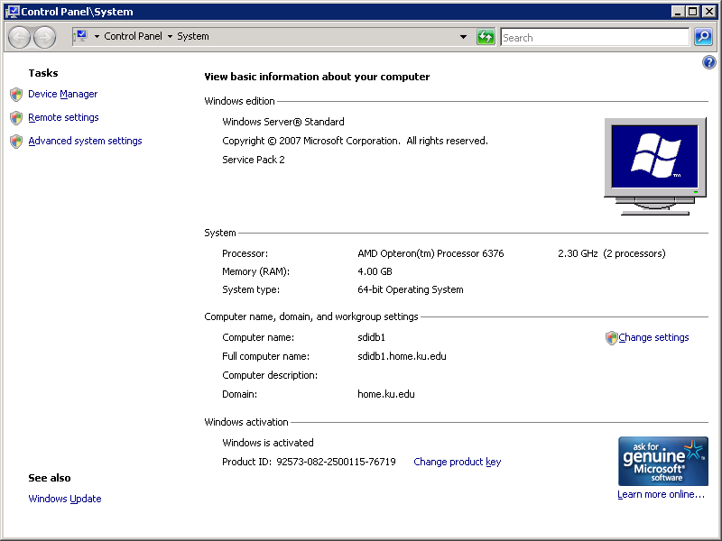

SQL server is 2014 **Express** edition with Service Pack 1.

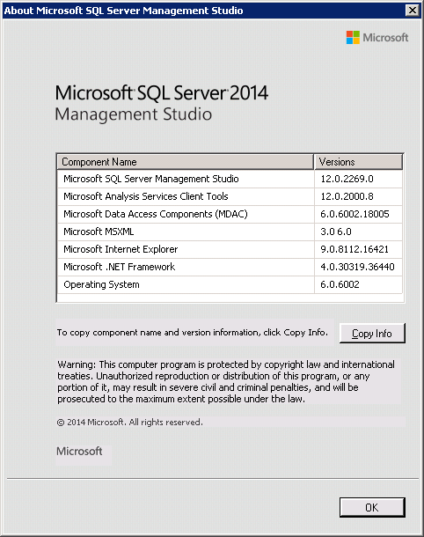

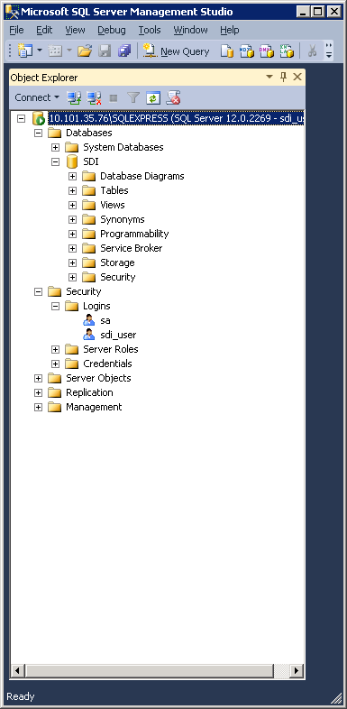

The SDI application database is SDI.

The user credentials for sdi_user were given to the DBA team.

Please note that this server does not have an agent to schedule backup or other jobs. Manual backups are needed.

An option to create a task in Windows could be considered.

1. **APPENDIX A - CREATING BACKUP IN PRODUCTION SQL**

Start SQL Server Management Studio (SSMS) and connect to the instance as system admin (sa).

Expand Management

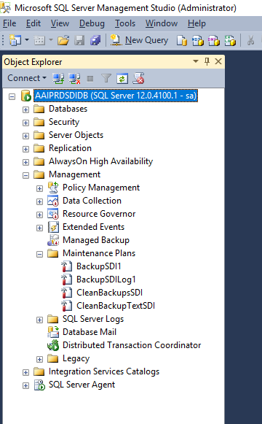

Right click on Maintenance Plans, then choose Maintenance Plan Wizard

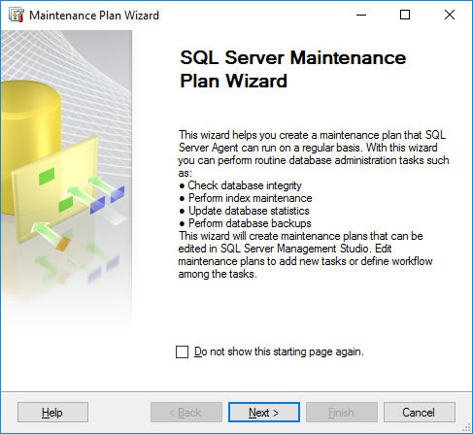

Click Next.

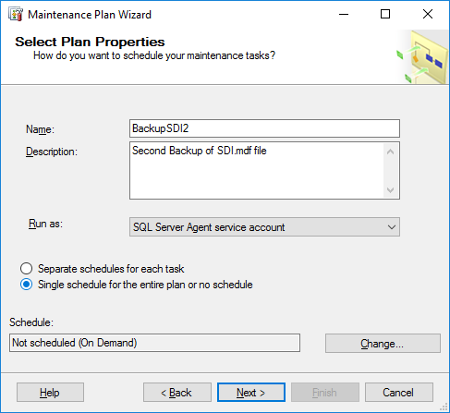

Enter a name and a description, then click Change to schedule the plan.

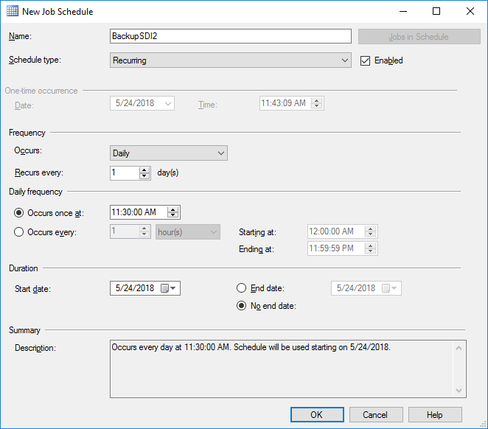

Click OK.

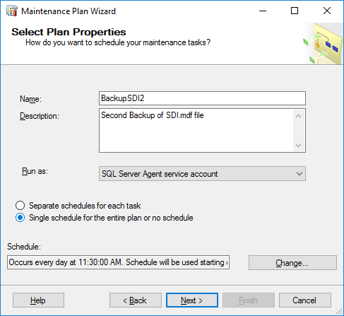

Click Next.

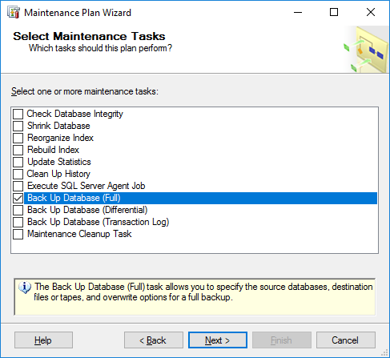

Click the check box for Back Up Database (Full), the click Next.

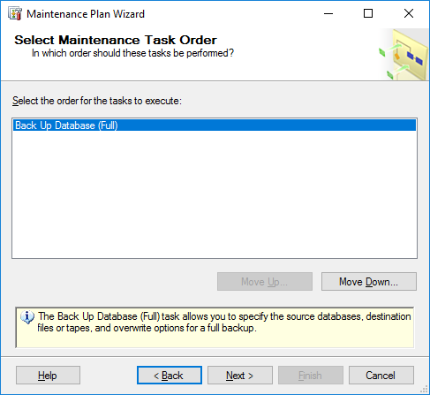

Click Next.

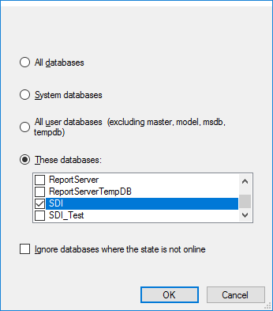

Check the database to be backed up (here SDI), then click OK.

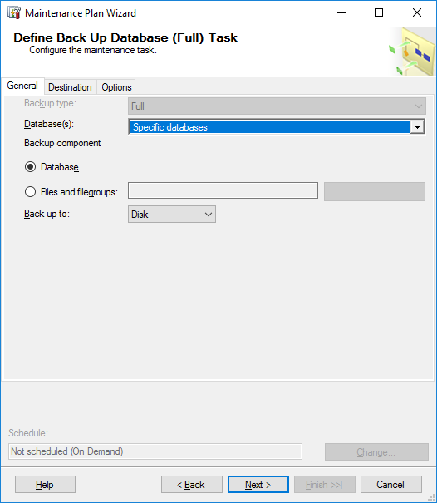

Click Next.

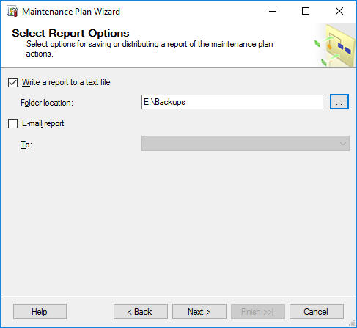

Select the location for the backup repot (optional)

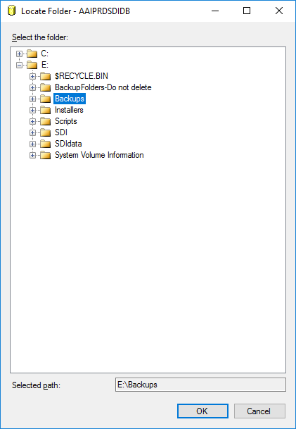

Click OK, then click Next

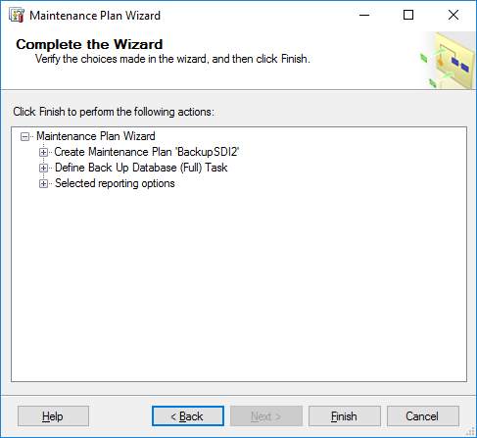

Click Finish. You should get this report

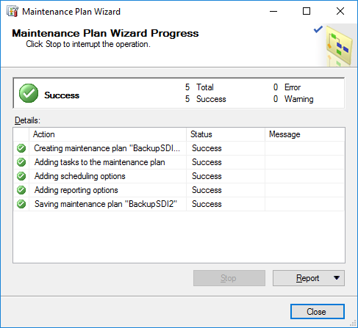

Click Close.

Double click on the newly created plan and you will see

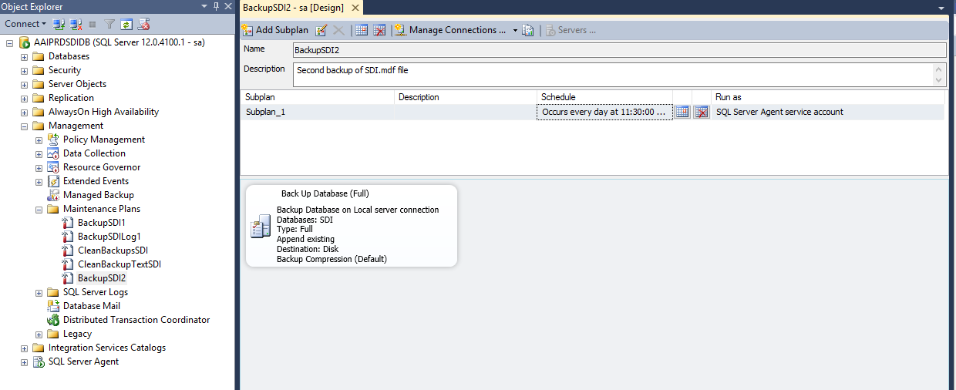

Double click on the plan and you will get

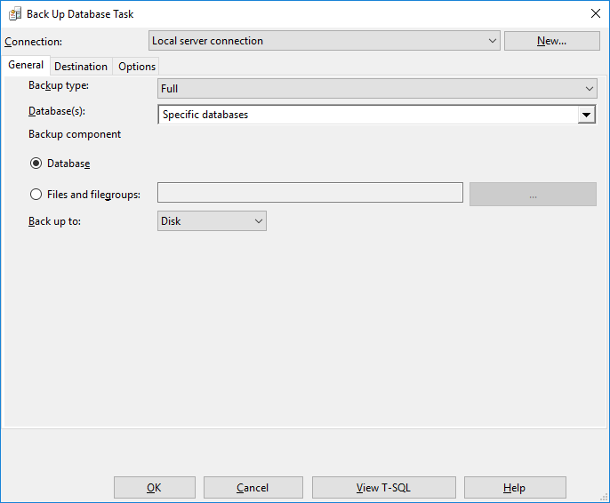

You may view the Transact SQL statement for the backup. When done click Close, then X out or click OK.

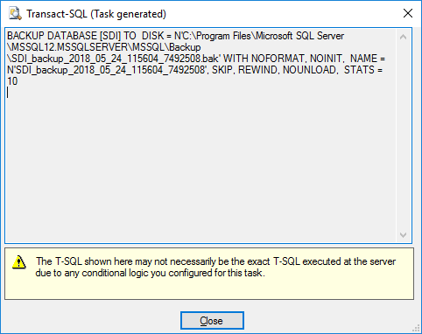

1. **APPENDIX B – DBA TASKS**

This appendix describes the DBA tasks in detail.

1. **Check server logs**

Click on the magnifier (search) icon and start typing Event Viewer.

Click on Event Viewer.

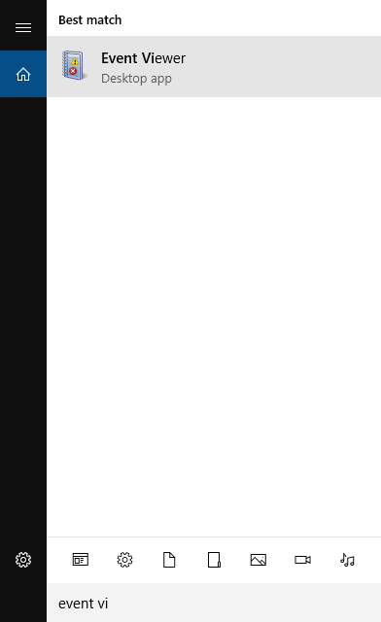

In Event Viewer expand Windows Logs. Then check the categories, especially Application and Security. Put emphasis on events with level of error (red) and warning (yellow).

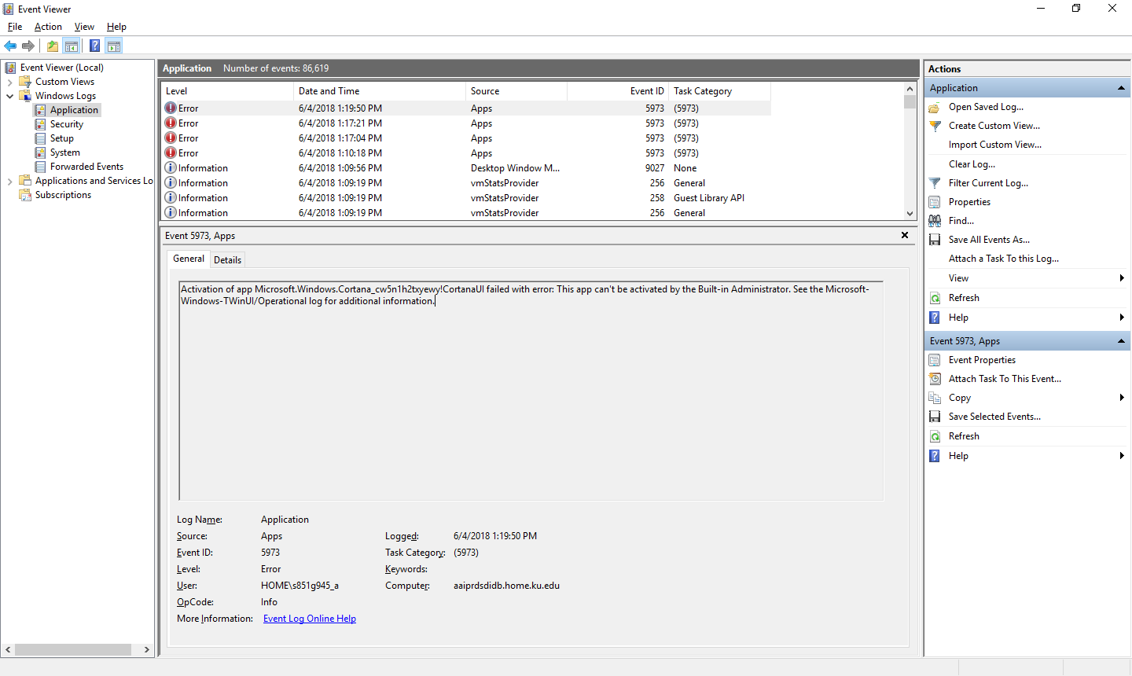

1. **Check CPU and memory use**

Click on the magnifier (search) icon and start typing Task Manager.

Click on Task Manager.

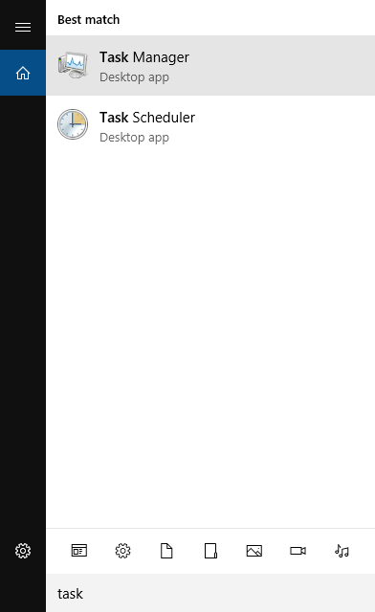

Check CPU, memory use, performance, and users.

If the utilization levels are high, you may need to check with the SDI team (Nathan), and/or OPS (Staley).

If there is a user who shows as logged out you may want to check with the user and possibly disconnect that user (they may have x’d out instead of logging out)..

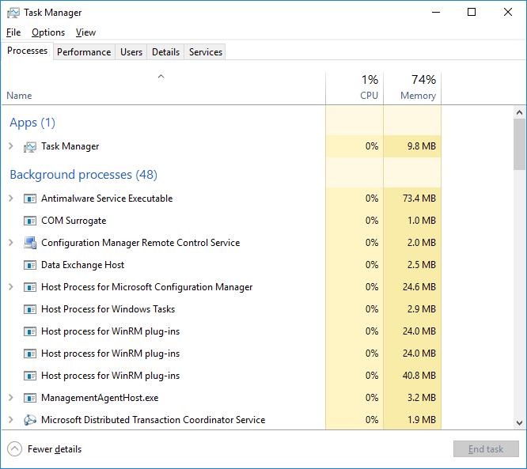

1. **Check partitions health**

Click on the magnifier (search) icon and start typing Computer Management.

Click on Computer Management.

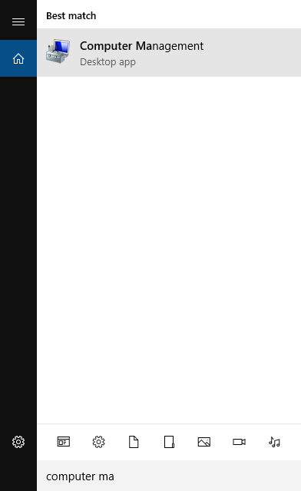

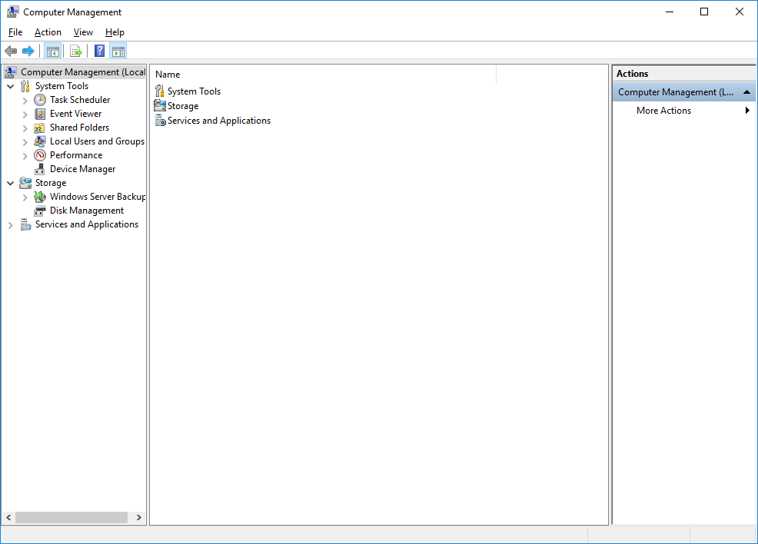

Click on Disk Management, and check status, capacity, free space.

If a partition is not healthy, or free space becomes small, please contact OPS (Staley).

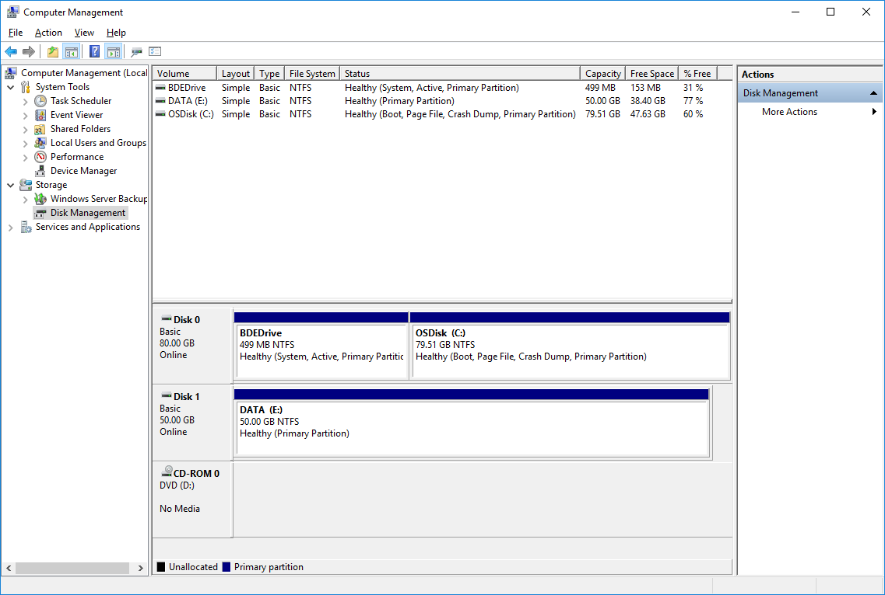

1. **Check database instance logs**

It is necessary to start SQL Server Management Studio in order to check logs.

In Object Explorer expand Management, SQL Server Logs.

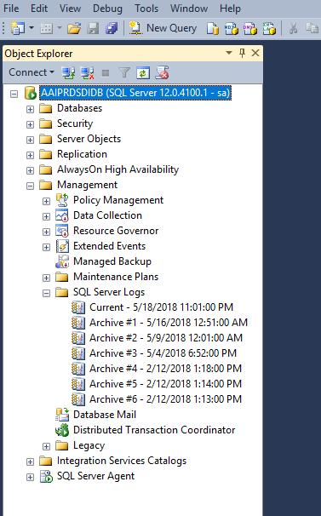

Expand the log of interest, such as, Current, and view entries.

You can maximize the window.

You can sort by date, source, and message. Also, you can filter the results.

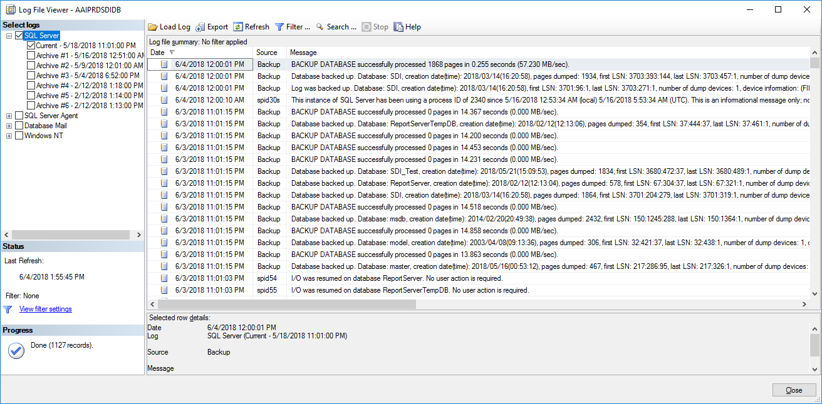

1. **Check database instance activity monitor**

It is necessary to start SQL Server Management Studio in order to check logs.

Click on the Activity Monitor icon

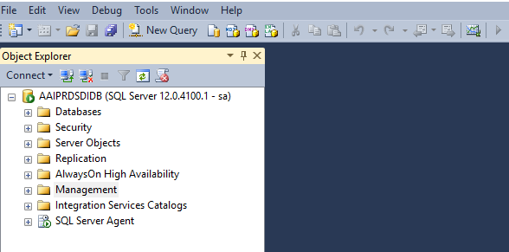

Now you can expand the tabs for Processes, Resource Waits, Data File I/O, and Recent Expensive Queries by clicking on the tabs. Clicking again will collapse them.

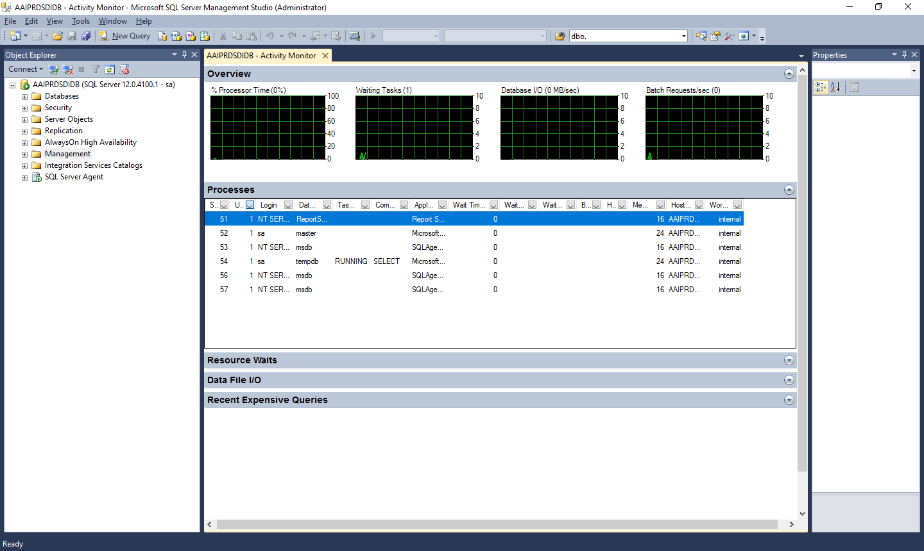

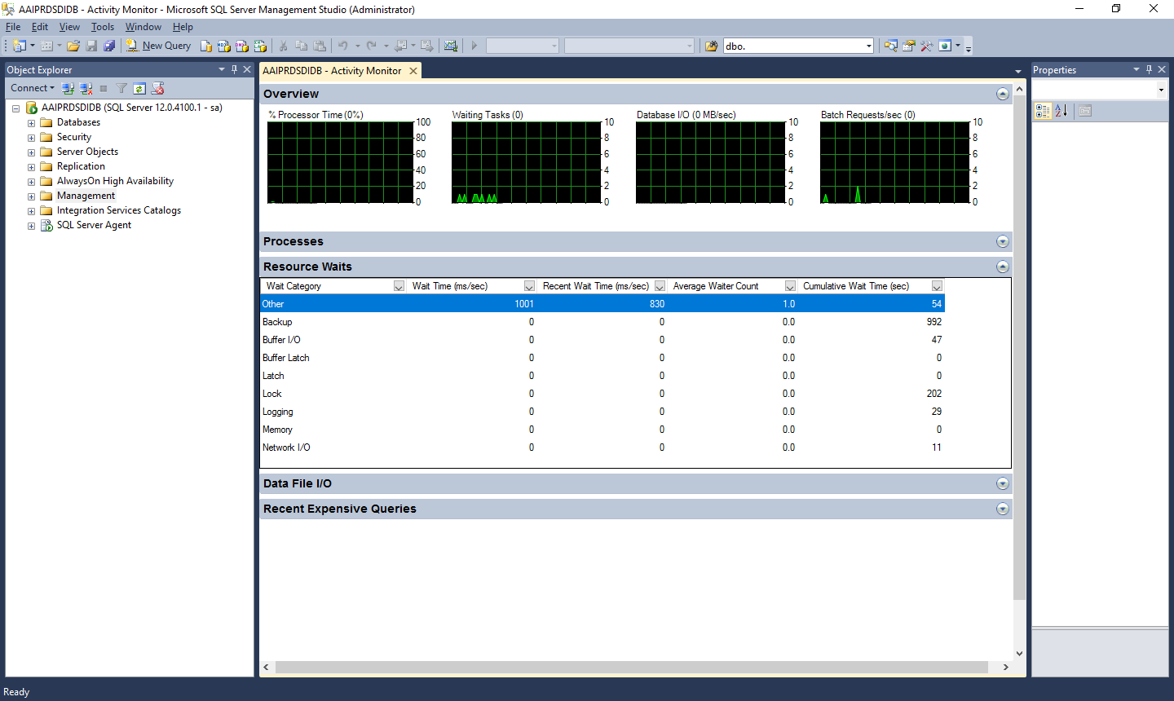

You can expand multiple tabs.

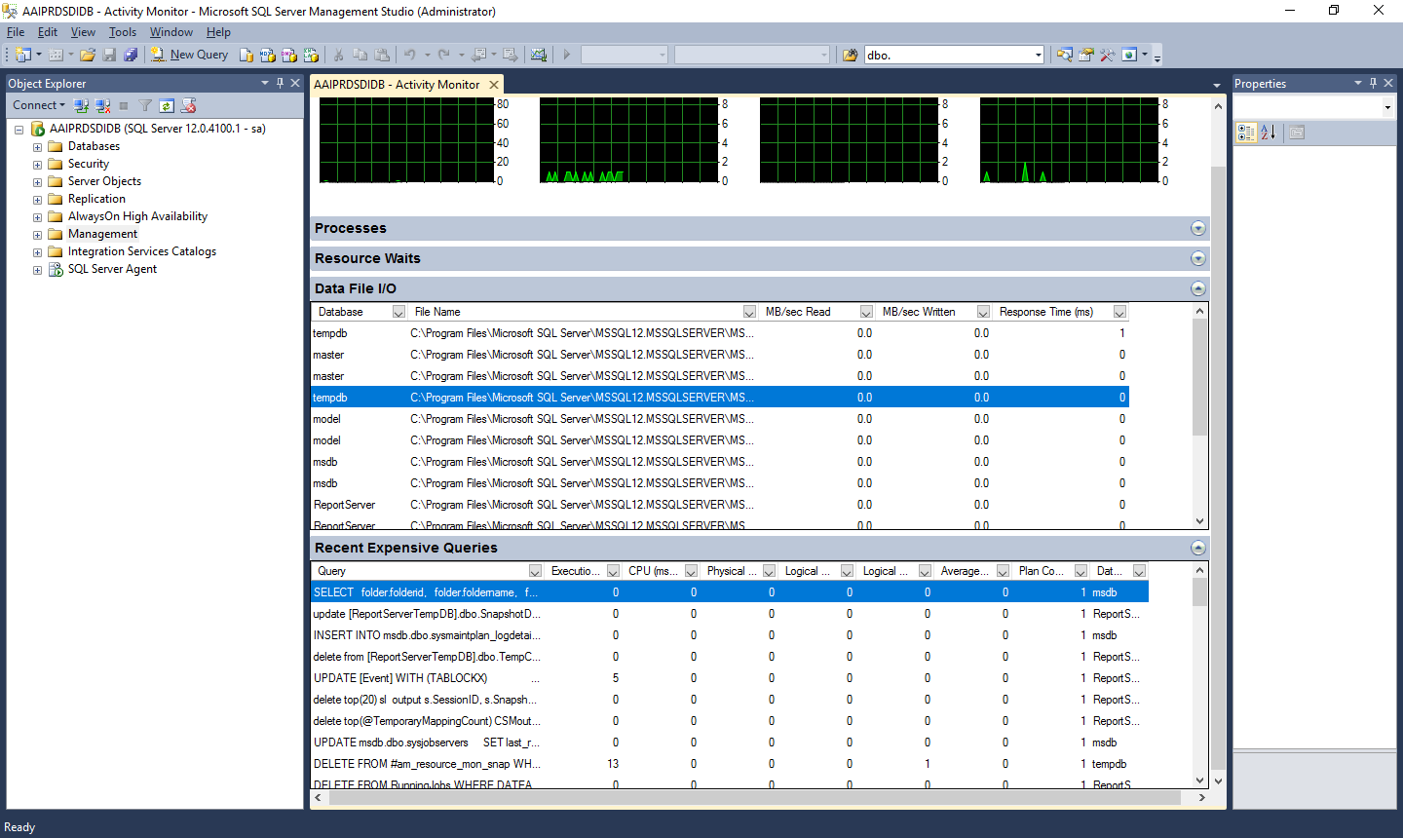

1. **Check backups in E:\Backups**

The backup files reside in the folder E:\Backups

Every day there should be .BAK files consisting of the SDI database backups for eight days, with two backups every day.

There should be eight sets of .txt files with backup logs of the database and a set for log files.

There should be two sets of eight .txt files for cleaning .BAK files and for cleaning .txt files that are older than eight days.

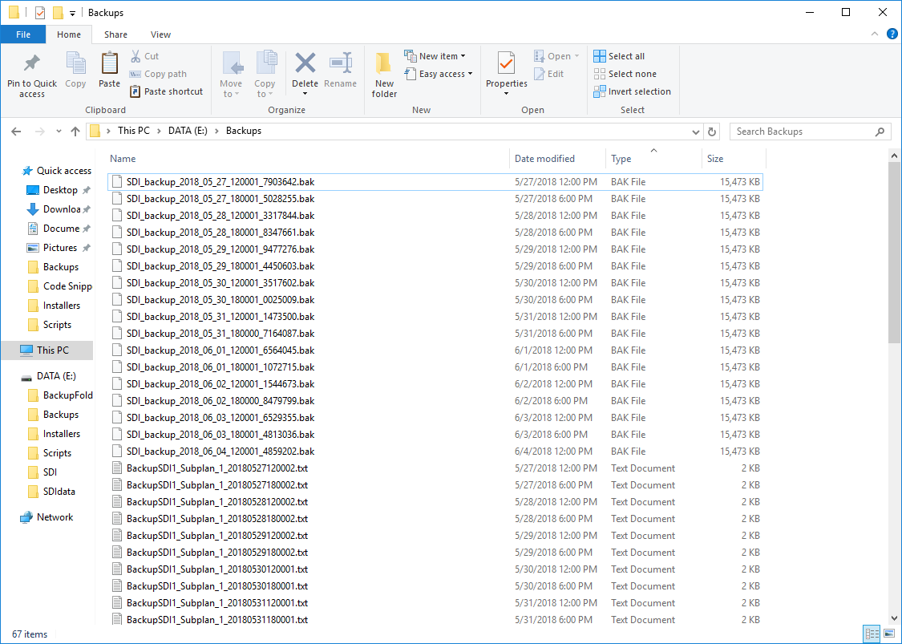

1. **Restore backups and compare data with that of the SDI database**

In order to perform a restoration test it is necessary to follow these steps carefully.

**Caveat: Make sure that you do not overwrite the production database, only the test database that is created for this test**.

It is necessary to start SQL Server Management Studio with sa credentials.

You can either create a new database, or use the existing SDI_Test database. The procedure is the same.

You need to verify or setup permissions for your user login account, to have full control in the folder E:\SDIdata.

If you choose to create a new database, e.g., SDI_Test2, make sure that files are set as follows

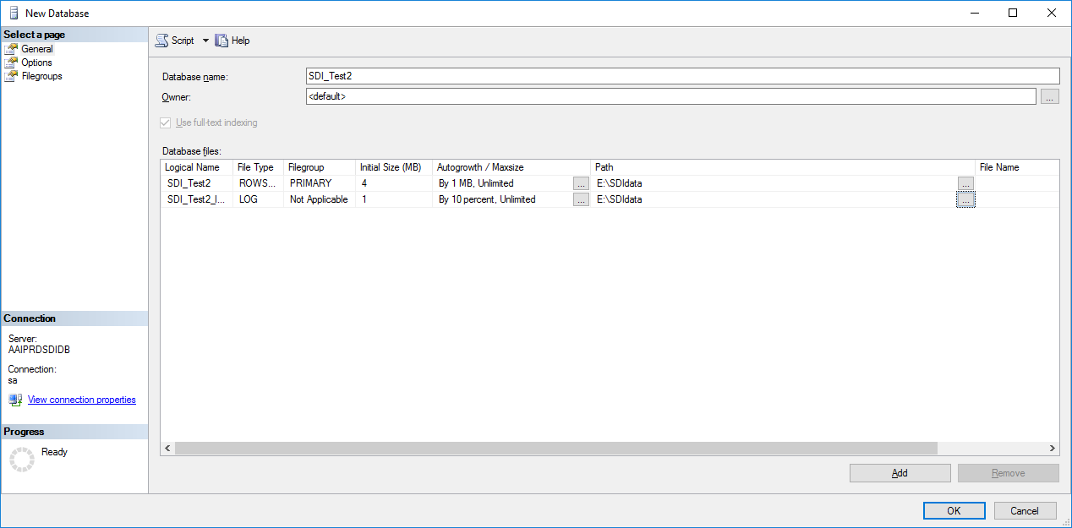

Please note that the file names will be entered for you, as can be seen when you look at database properties after it has been created.

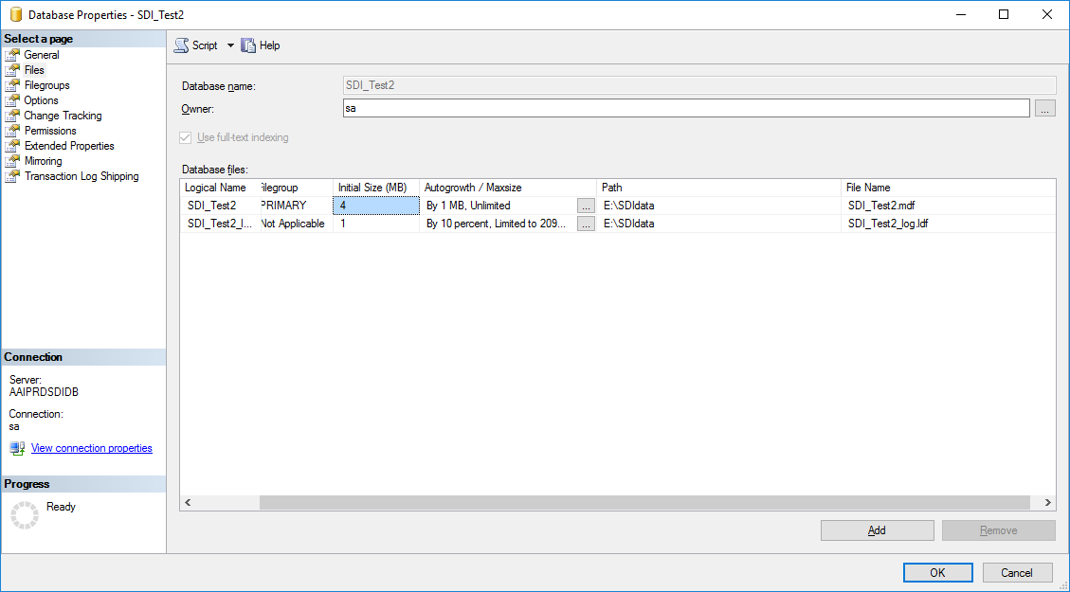

Right click on the destination (test) database. Choose Tasks, Restore, Database

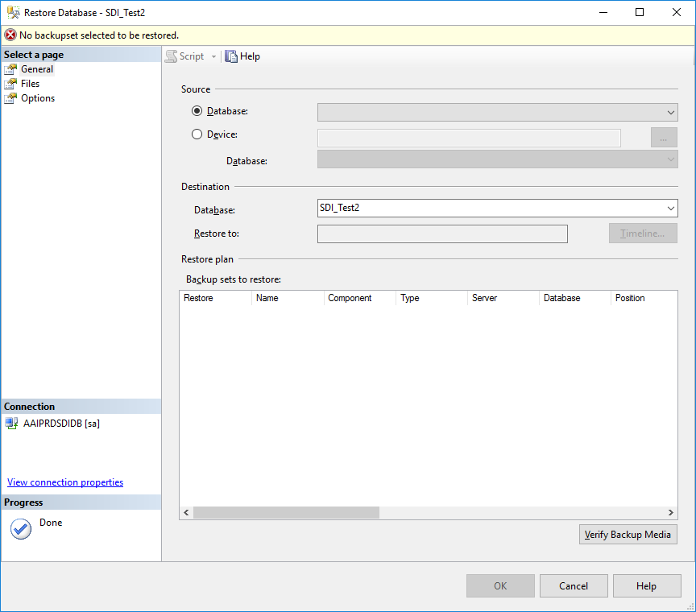

Select Device and click on the ellipsis

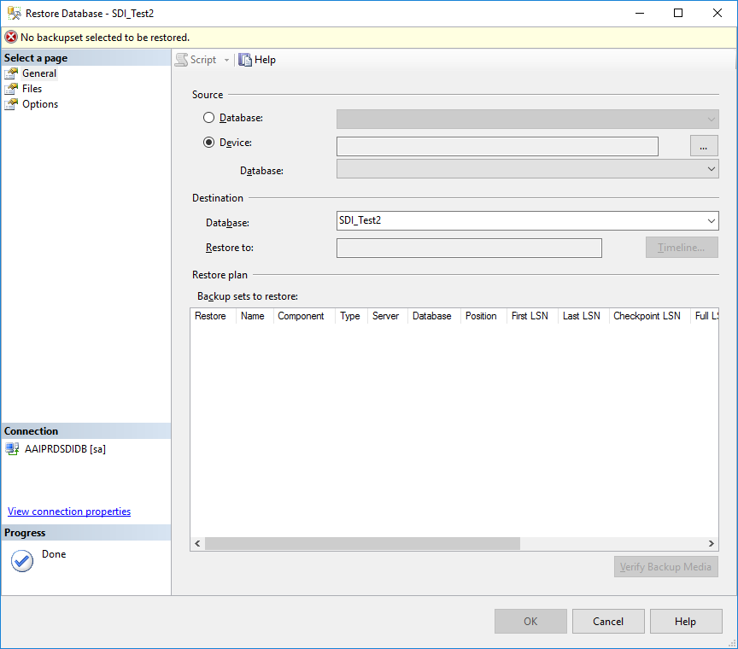

Click on Add

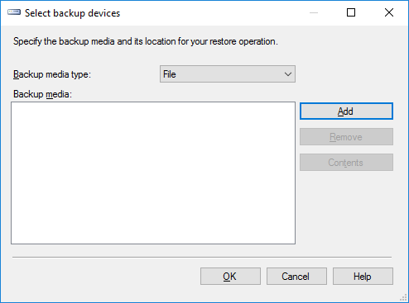

Select the folder that contains the SDI backups, E:\Backups

Click on the folder and choose the backup to restore, usually the latest one available.

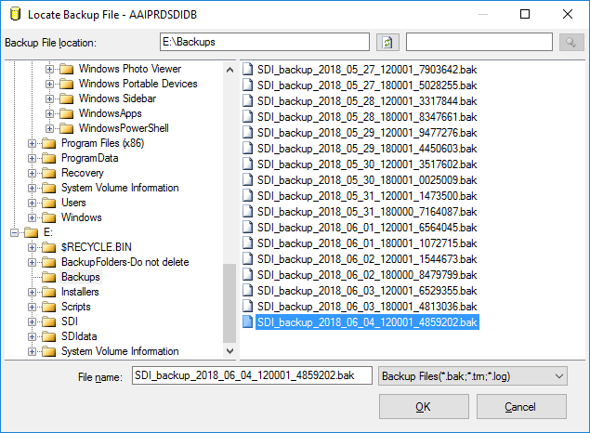

You will see the selection now

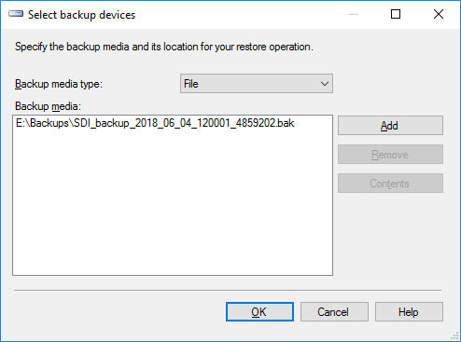

Click OK.

The main restore windows shows now

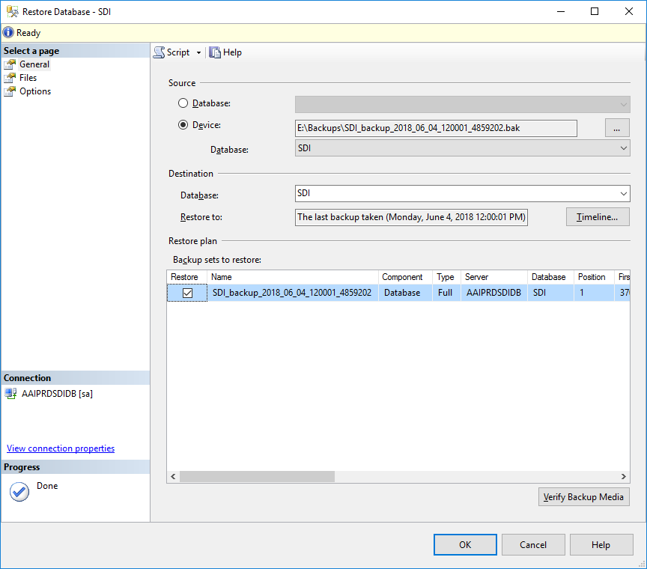

**DO NOT CLICK OK YET!**

Click on Files – THIS IS VERY IMPORTANT. YOU MSU CHANGE THE Restore As file names, or you will replace the existing production database by the backup!

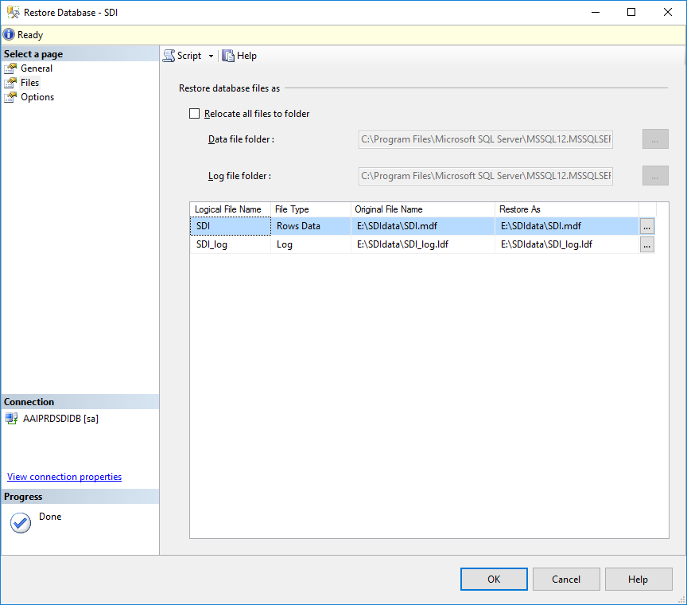

Change the file names to those of the test database.

This is done manually by typing the correct file names.

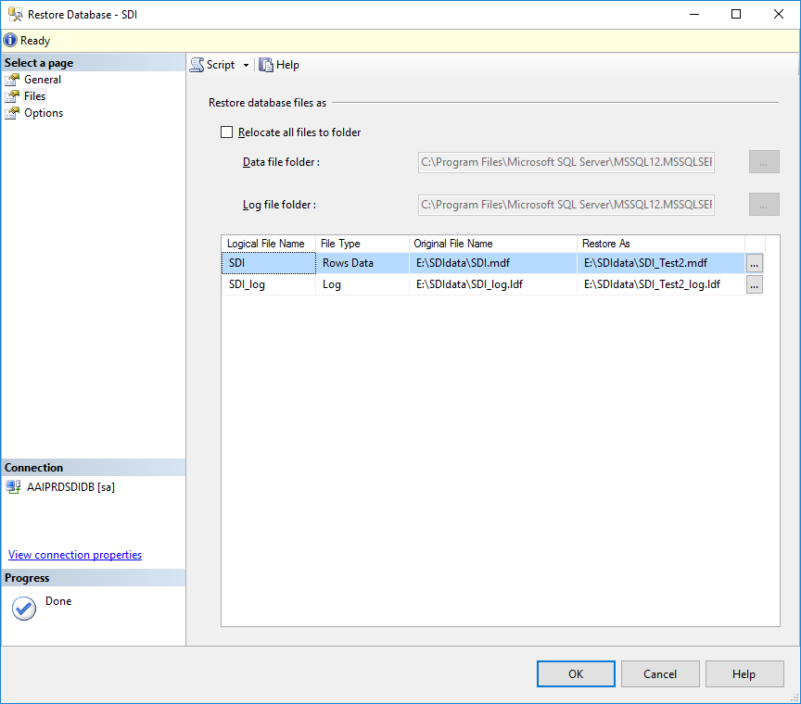

**DO NOT CLICK OK YET!**

You need to choose the option to overwrite the existing database – this is the test database, not production! Click on the box as shown.

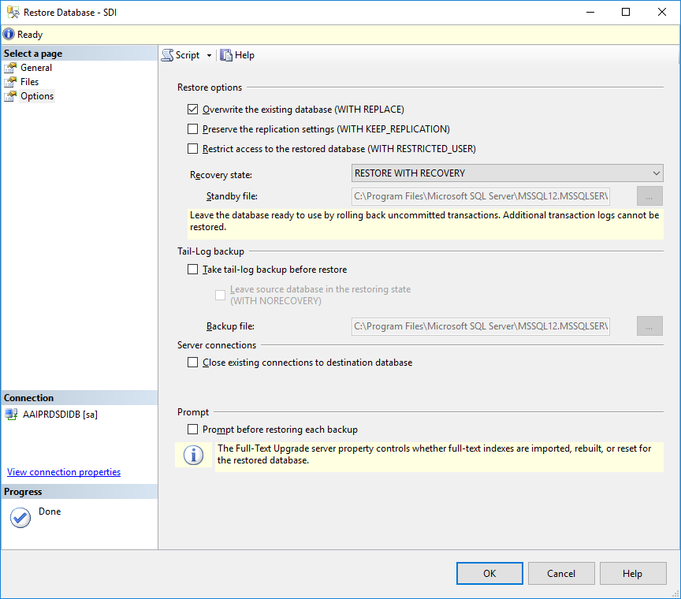

Now you may click OK to start the restoration.